 | Student Name _______________________  Eastern Goldfields College  Unit 3/4 Essentials Mathematics 2018  Application 1 – Layton’s Feature Circle  Formula sheet allowed
Class time allocated: 90 minutes Weighting 9% Total Marks: 48

Layton has just moved into a new house and is looking at landscaping his backyard. He wants a circular brick-paved feature within his garden. Around the feature he wishes to have a row of cobblestones as a border.

Layton needs some help to decide what size his brick-paved feature should be and to work out how much it is going to cost.

ROUND YOUR ANSWERS TO 3 DECIMAL PLACES

1. [2 marks]
Calculate the circumference of a circle with radius 0.5 m.

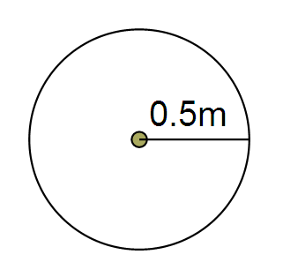

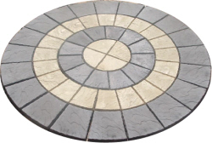

2. [2 marks]
Calculate the area of a circle with radius 0.5 m.

3. [2 marks]

- Which measurement best describes the amount of cobblestones required? (Please circle)

CIRCUMFERENCE AREA

- Which measurement best describes the amount of bricks required? (Please circle)

CIRCUMFERENCE AREA

Layton would like to investigate different possible sizes for his feature.

4. [1, 1, 1 = 3 marks]
Calculate the circumference of each circle below.
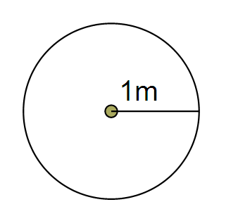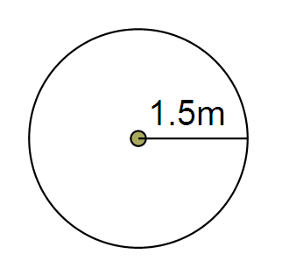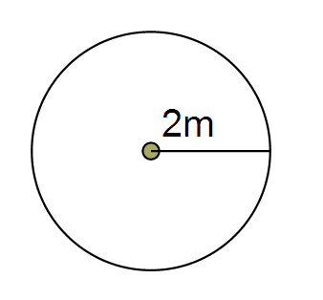
(a) (b) (c)

5. [1 mark]
Use your answers from questions 1 and 4 to complete the table below.

Radius of Circle  (m) | Circumference of Circle  (m)

6. [2 marks]
When the radius of a circle is doubled, does the circumference also double? (Show evidence/calculations to support you answer.)

7. [2 marks]
When the radius of a circle is tripled (three times as long), what happens to the circumference? Does it also triple? (Show evidence/calculations to support you answer.)

8. [1, 1, 1 = 3 marks]
Calculate the area of each circle below.
(a) (b) (c)

9. [1 mark]
Use your answers from questions 2 and 8 to complete the table below.

Radius of Circle  (m) | Area of Circle  (m²)

10. [3 marks]
When the radius of a circle is doubled, does the area also double? (Show evidence/calculations to support you answer.) If not what is happening?

11. [3 marks]
When the radius of a circle is tripled (three times as long), what happens to the area? Does it also triple? (Show evidence/calculations to support you answer.) If not what is happening?

Price List Brick Pavers (feature) $65 per m²
Cobblestones (border) $9.50 per 1m of border

12. [3 marks]
Layton decides to make a circular feature with a radius of 1m. Using the price list above, how much will Layton’s feature cost in total?

13. [2 marks]
Layton then realises that he could afford to build a bigger feature. He decides to double the radius. Without doing calculations, do you think that the new cost will be

  - less than double the original cost?

  - exactly double the original cost?

  - More than double the original cost?

[Circle correct answer]

Explain your choice.

- [3 marks]
Calculate the total cost of the new feature (with the doubled radius).

- [2 marks]
Is the new cost less than, more than or exactly double the original cost? (Show evidence/calculations to support your answer).

50 cm
50 cm
50 cm
50 cm

16. [4 marks]
For the design above calculate the area to be paved by the light coloured pavers.

17. [2 marks]
What percentage of the design will be covered by the light pavers?

18. [8 marks]
Layton has also laid some new turf in another section of his backyard that is rectangular in shape and measures 9 m wide and 13 m long. He now needs to reticulate this area by installing a sprinkler system to keep his lawn lush and green throughout the hot summer months.
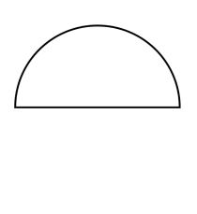
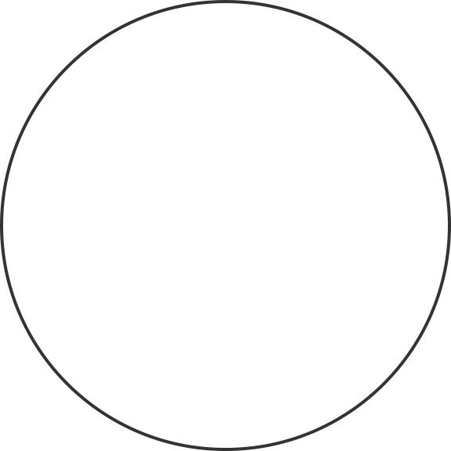
He has purchased different sprinkler heads that can be set to quarter, half or full circle modes. Each has a spray radius of 2.3 m
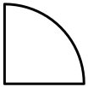

- Use the graph paper provided to make a scale drawing plan of the lawn.
- Use a scale of 1:100
- Clearly show where the sprinkler heads are positioned and the spray area they will cover.
- State how many of each sprinkler type you have used in your layout.

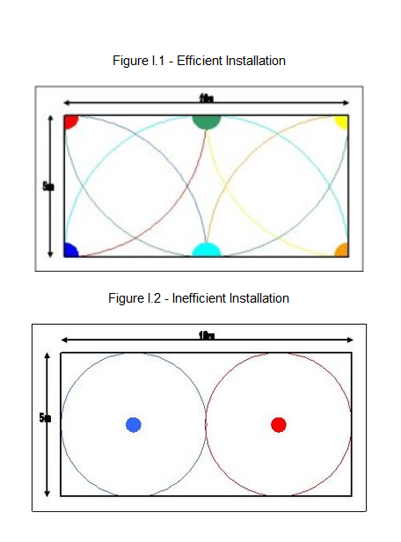
To design and install an efficient water-wise system, bear in mind the following points.
"Head to Head" coverage - sprinklers should be installed so that one sprinkler sprays onto the adjacent sprinkler. Please see the drawings below which show a 10m x 5m lawn area with 6 sprinkler heads (figure I.1) and one with 2 sprinklers (figure I.2).
The first configuration means that there are no dry spots and that due to the overlapping of each sprinklers wetted area the run time for the zone can be reduced. The second has dry spots and so the area needs to be watered for excessive durations to provide water to these dry spots.
It is better to spray from the edge of lawn and garden areas into the middle. So, it is better to position your sprinklers around the edge. (see figure I.1) If the area is wider than the radius of the sprinklers used then more sprinklers should be placed in the middle.

END OF INVESTIGATION

